

**ONLINE EXAMINATION SYSTEM**

A COURSE PROJECT REPORT-I

By

**RISHABH SINGH SAHIL (RA2011003011334)**

**A BHISHEK VERMA (RA2011003011341)**

**NIKHIL KAR (RA2011003011346)**

Under the guidance of

**Mr. N.A.S VINOTH**

*In partial fulfilment for the Course*

of

18CSC303J – Database Management System



**FACULTY OF ENGINEERING AND TECHNOLOGY SRM INSTITUTE OF SCIENCE AND TECHNOLOGY**

**Kattankulathur, Chengalpattu District**

FEBRUARY 2023

**SRM INSTITUTE OF SCIENCE AND TECHNOLOGY**



**(Under Section 3 of UGC Act, 1956)**

**BONAFIDE CERTIFICATE**

Certified that this mini project report "**Online Examination System**" is the Bonafide work of **Rishabh Singh Sahil (RA2011003011334), Abhishek Verma (RA2011003011341)** and **Nikhil Kar (RA2011003011346)** who carried out the project work under my supervision.

### SIGNATURE

Mr.N.A.S Vinoth Assistant Professor

Department of Computing Technologies SRM Institute of Science and Technology

## ACKNOWLEDGEMENT



We express our heartfelt thanks to our honorable **Vice Chancellor, Dr. C. Muthamizhchelvan,** for being the beacon in all our endeavors.

We would like to express my warmth of gratitude to our **Registrar, Dr. S. Ponnusamy,** for his encouragement.

We express our profound gratitude to our **Dean (College of Engineering and Technology), Dr. T. V. Gopal**, for bringing out novelty in all executions.

We would like to express my heartfelt thanks to **Chairperson, School of Computing, Dr. Revathi Venkataraman**, for imparting confidence to complete my course project.

We extend my gratitude to our **HoD, Dr. M. Pushpalatha, Head and Professor, Department of Computing Technologies.**

We are highly thankful to our **course project faculty, Mr. N.A.S Vinoth, Assistant Professor, Department of Computing Technologies** for her assistance, timely suggestion and guidance throughout the duration of this course project and my Departmental colleagues for their support.

Finally, we thank our parents and friends near and dear ones who directly and indirectly contributed to the successful completion of our project. Above all, I thank the almighty for showering his blessings on me to complete my Course project.

# TABLE OF CONTENTS



|  |  |  |
| --- | --- | --- |
| **Chapters** | **Content** | **Page No.** |
| **1** | Abstract | 5 |
| **2** | Introduction | 6 |
| **3** | Problem Statement | 7 |
| **4** | Objectives | 8 |
| **5** | Approach | 9 |
| **6** | ER diagram | 10 |
| **7** | Scope | 11 |
| **8** | How our solution differs | 12 |
| **9** | Architecture Diagram | 13 |
| **10** | Work-Output | 14 |
| **11** | References | 15 |
| **12** | Summary | 16 |



* Online Examination System is web-based application for technical evaluation.
* It not only replaces paperwork but also releases the workload of the faculty.
* It fulfills the requirements of the institute to conduct the exams online. Students can give exam without need of going to any physical destination.
* The required software and hardware are easily available and easy to work with.
* Online Examination System, as described above, can lead to error free, secure, reliable and fast management
* It can assist the user to concentrate on their other activities rather to concentrate on the record keeping.
* Thus, it will help organization in better utilization of resources. The organization can maintain computerized records without redundant entries.
* That means that one need not be distracted by information that is not relevant, while being able to reach the information.



The "Online Examination System" has been developed to override the problems prevailing in the practicing manual system. This software is supported to eliminate and, in some cases, reduce the hardships faced by this existing system. Moreover, this system is designed for the particular need of the company to carry out operations in a smooth and effective manner.

Online Examination System can lead to error free, secure, reliable and fast management system. It can assist the user to concentrate on their other activities rather to concentrate on the record keeping. Thus, it will help organization in better utilization of resources.

This is designed to assist in strategic planning, and will help you ensure that your organization is equipped with the right level of information and details for your future goals. Also, for those busy executive who are always on the go, our systems come with remote access features, which will allow you to manage your workforce anytime, at all times. resources.



* Since the traditional have many drawbacks such as:
  1. Time consuming
  2. Difficulty of analyzing the test manually
  3. More observers are required to take exam of many students
  4. Results are not accurate since calculations is done manually
  5. The chance of losing exam's result is higher in current systems
  6. Checking of result is time consuming since it done manually
  7. Limited no of students can give examination at a time.
* With the development of information technology and use it in an orderly and properly helps to overcome the existing error in the manual system.
* Online examination system saves the exams information in a database
* This make it an easier way to give exam teachers can add their exams rules, and student can give exam in a totally automated system.



* The main objective of the Project on Online Examination System is to manage the details of Exam, long question, short question, true-false question, matching question.
* It manages all the information about exam, answer, matching question, exam.
* The project is totally built at administrative end and thus only the administrator is guaranteed the access.
* Economic feasibility
* Time flexibility
* Technical feasibility
* User-friendly interface
* Eco-friendly System



# Existing Approach

The Existing system of conducting examination process is manual. Existing system is a large man power process and is difficult to implement it at different platform. It has so many problems. So, we introduce an Online Examination system, which is fully computerized. Existing system is a large man power process and is difficult to implement.

The following drawbacks of existing system emphasize the need for computerization:

* + - a lot of copies of question papers have to be made
    - a lot of correction work hence delays in giving the results
    - a lot of tabulation works for each subject results



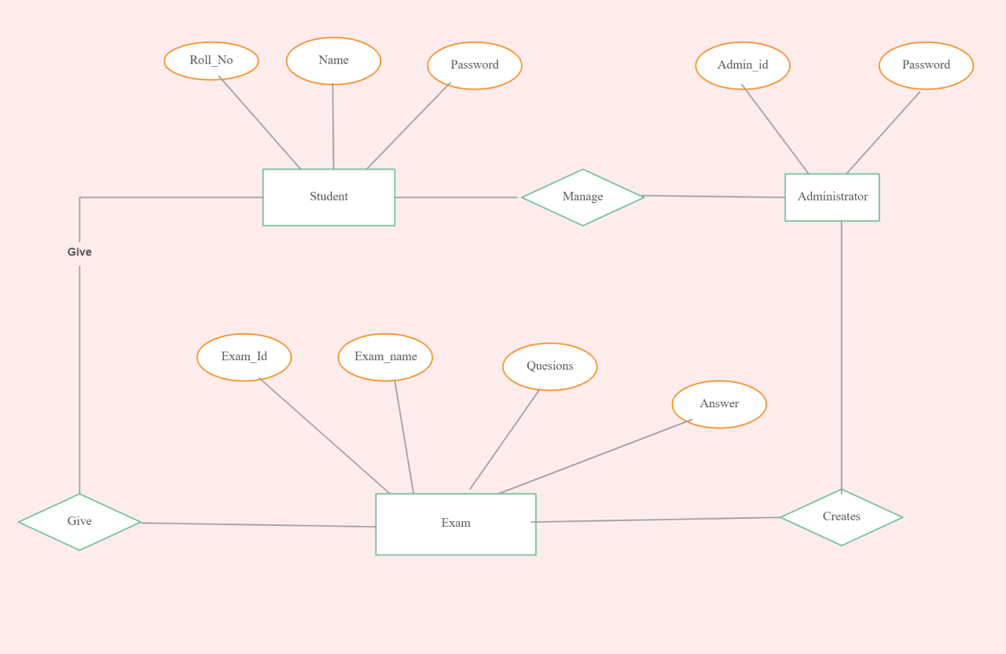.



It may help collecting perfect management in details. In a very short time, the collection will be obvious, simple and sensible. It will help person to know the management of passed year perfectly and vividly. It also helps in current all works relative to Online Examination System. It will also reduce the cost of collecting the management & collection procedure will go on smoothly.

* In computer system the person has to fill the various forms & number of copies of the forms can be easily generated at a time.
* In computer system, it is not necessary to create the manifest but we can directly print it, which saves our time.
* To assist the staff in capturing the effort spent on their respective working areas.
* To utilize resources in an efficient manner by increasing their productivity through automation.
* The system generates types of information that can be used for various purposes.



Low internet connection would be sufficient to load the pages, since we haven’t used any picture data (using pictures the user with low internet connection takes time to load the images). In other online exam system websites, we can find only one admin who is surely responsible for the addition or deletion of the test, but we made this site any number of authorized persons can add/remove the examinations and these all authorized persons and users of this site will be controlled by the admin. It could be very helpful for educational institutes acting as:

* Admin --- director of institute
* Teacher --- professors of college
* User --- students of the college
* home page Security with password, even the admin cannot look at the password , ensuring the trust of the users. A feedback system available for suggesting improvements and registering complaints.



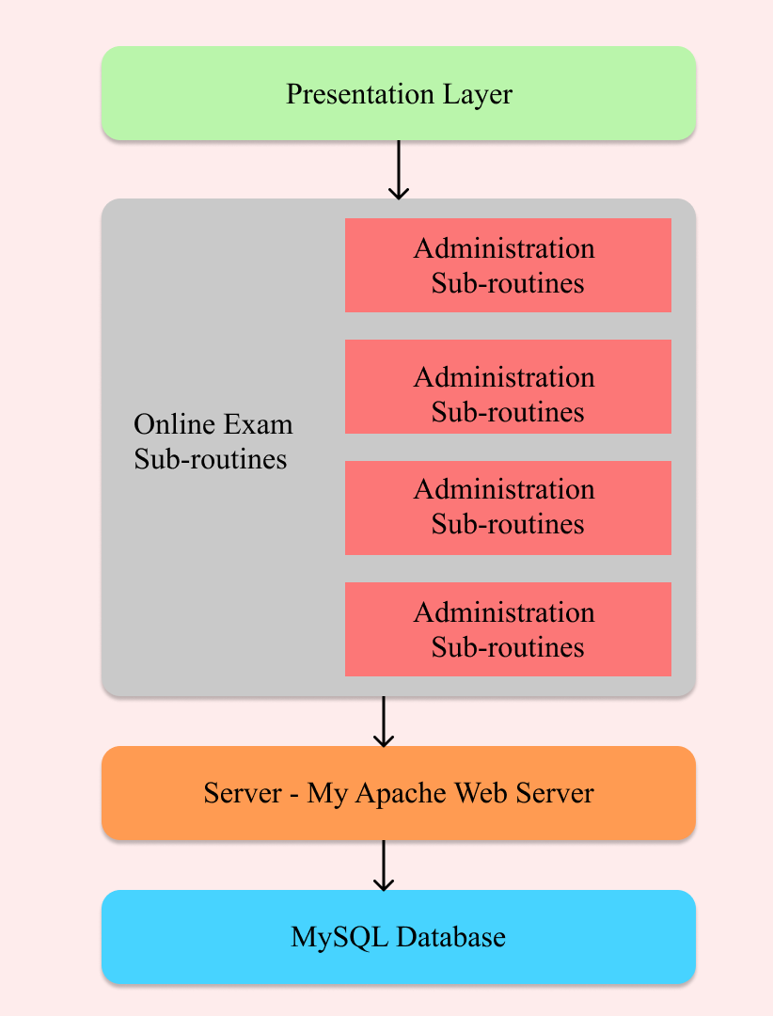

**Sign-Up / Login Page:**

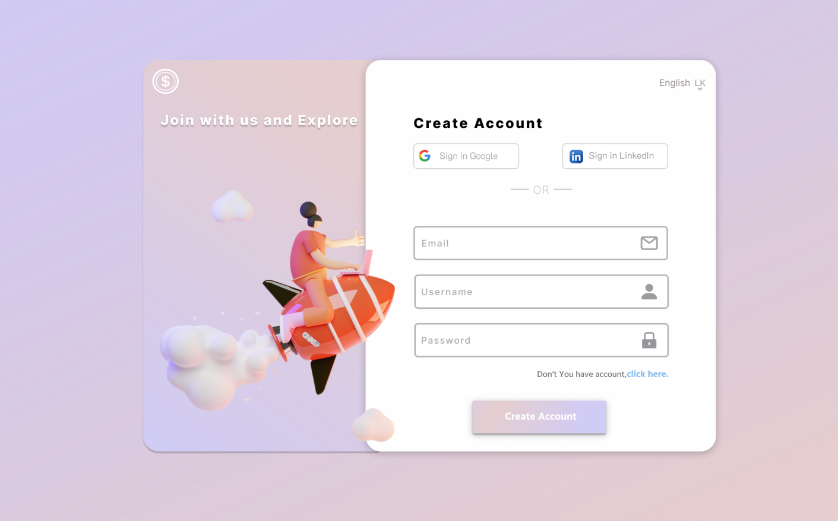

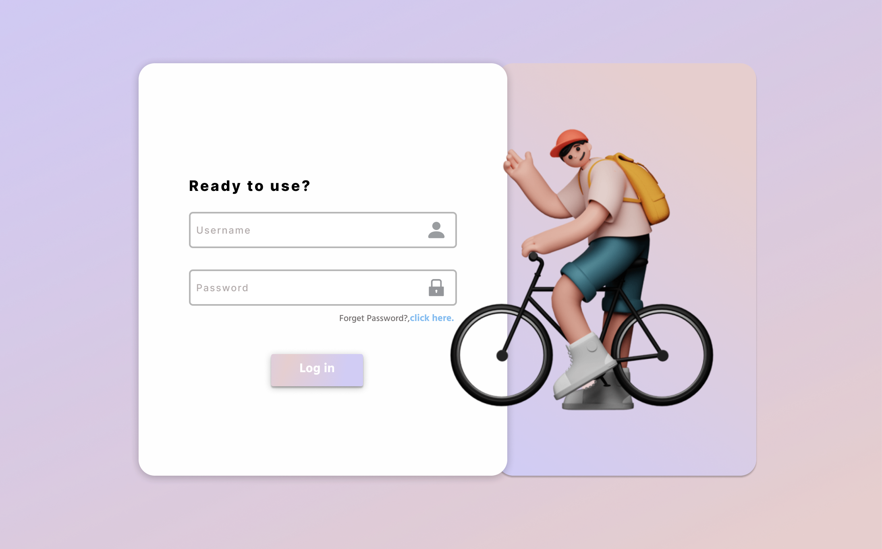



* https://[www.eklavvya.com/blog/online-examination-system/](http://www.eklavvya.com/blog/online-examination-system/)
* https://ieeexplore.ieee.org/
* https://[www.researchgate.net/](http://www.researchgate.net/)



* Online Examination System is a web application.
* The key concept is to minimize the amount of paper and convert all forms of documentation to digital form.
* It can be observed that the information required can be obtained with ease and accuracy in the computerized system.
* The user with minimum knowledge about computer can be able to operate the system easily. The system also produces brief result required by the management.
* Developments in software technology are continuing dynamically. This has forced developers to look for new approaches to design and development.
* In order to face this situation, the modules in a package should be upgraded any time.
* The modules in this package can be subjected to further enhancements.